SALES DATA ANALYSIS REPORT

- Objective
To analyse Kaggle’s Sample Sales Data using Python and Pandas to derive actionable business insights- identifying top-performing products, regions, and key sales trends.

- Dataset Overview
Contains approximately 2,800 records with attributes such as Order Number, Quantity Ordered, Price Each, Sales, Product Line, Country and Deal Size

- Tools Used
• Python 3
• Pandas- For data loading & aggregation
• Matplotlib/Seaborn- For visualization
• Jupyter Notebook- For execution of code

4) Analysis Performed
1. Data Inspection
Dataset loaded successfully and checked for null values- no major data quality issues found.
2. Descriptive Statistics
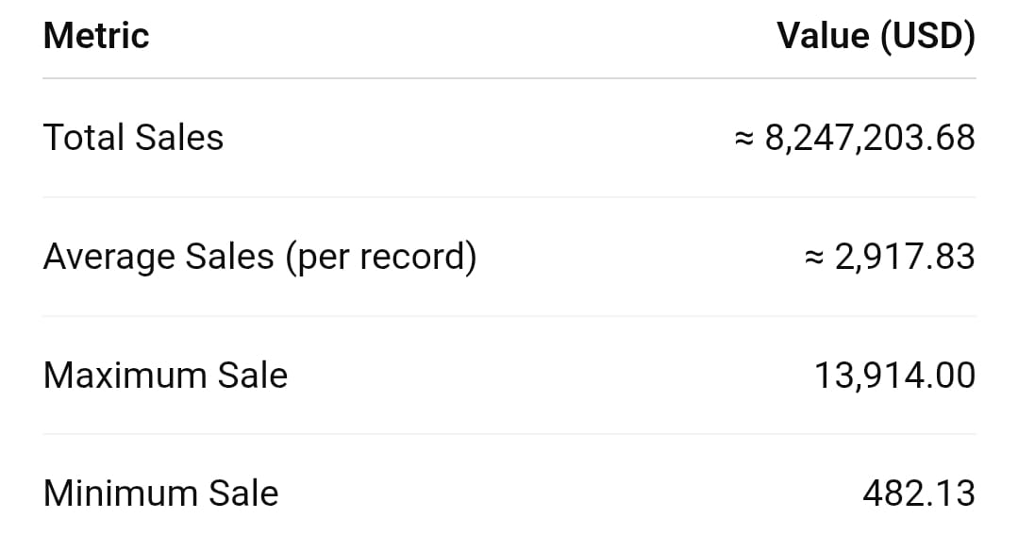
Sales range from small retail transactions to large enterprise orders.
3. Product Line Performance
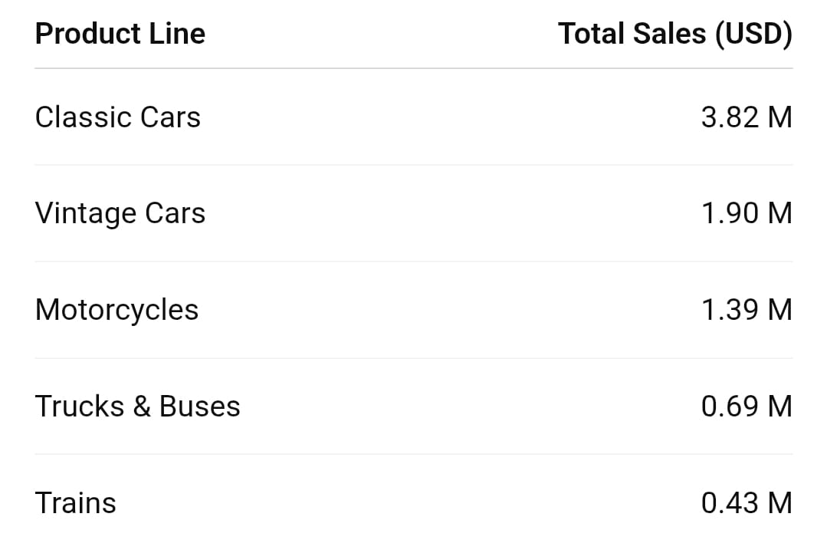
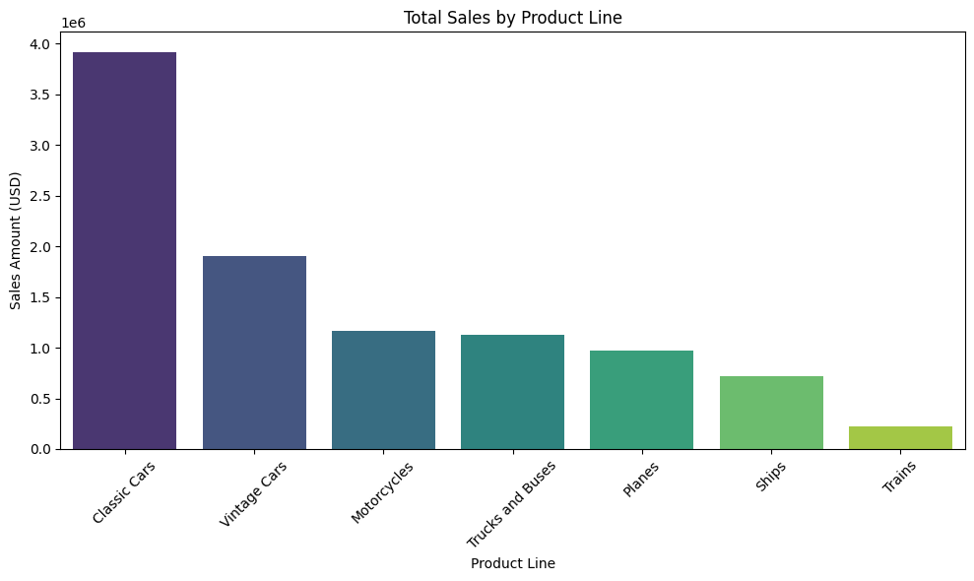
Figure 1: Total Sales by Product Line
Insight: Classic Cars lead sales with approximately 46% share- the company’s flagship segment.
4. Country Performance
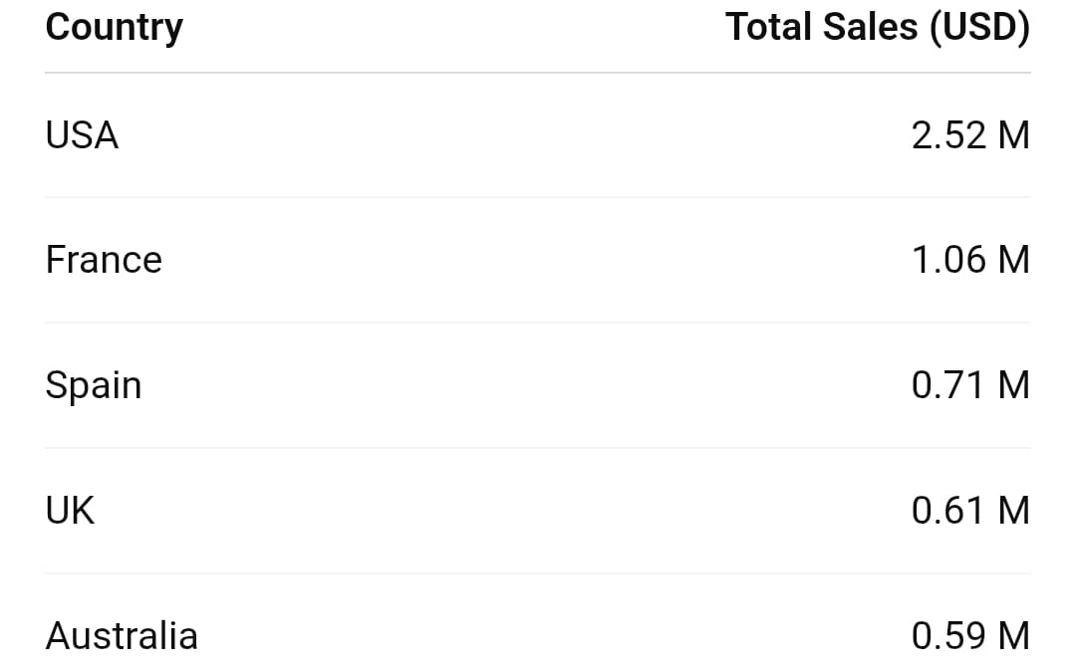
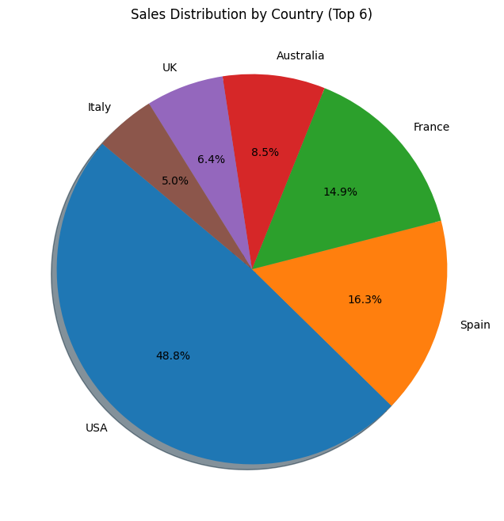
Insight: USA is the primary market, followed by France and Spain. Marketing focus should remain strong here.

5. Top 5 Products
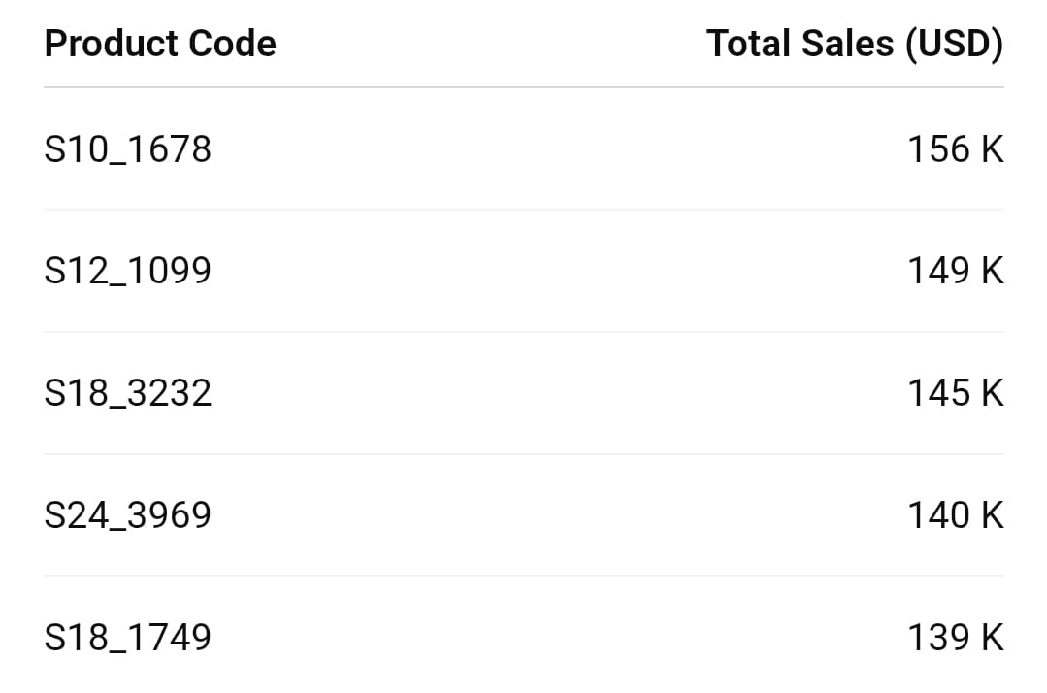
These belong mainly to the Classic Cars line.

- Visualizations
• Bar Chart- Product Line vs Total Sales: Classic Cars stand out strongly.
• Pie Chart- Top 6 Countries: USA contributes to approximately 30% of total sales.

- Key Business Insights
• Classic Cars category drives nearly half of total revenue.
• United States and France are core markets with high volume.
• Large deals contribute most revenue and this, focus should be on premium clients.
• Trucks/Buses and Trains are low revenue segments and hence, this is a possible strategy review
• Sales show steady quarterly trend with seasonal peaks in Q3 and Q4.

- Conclusion
This analysis demonstrates how Python analytics can extract actionable insights from raw sales data. Focusing on high-performing product lines and top regions can enhance profitability and guide data-driven decision making.

